1. Design DFA using simulator to accept the string having ‘ab’ as substring over the set {a,b}

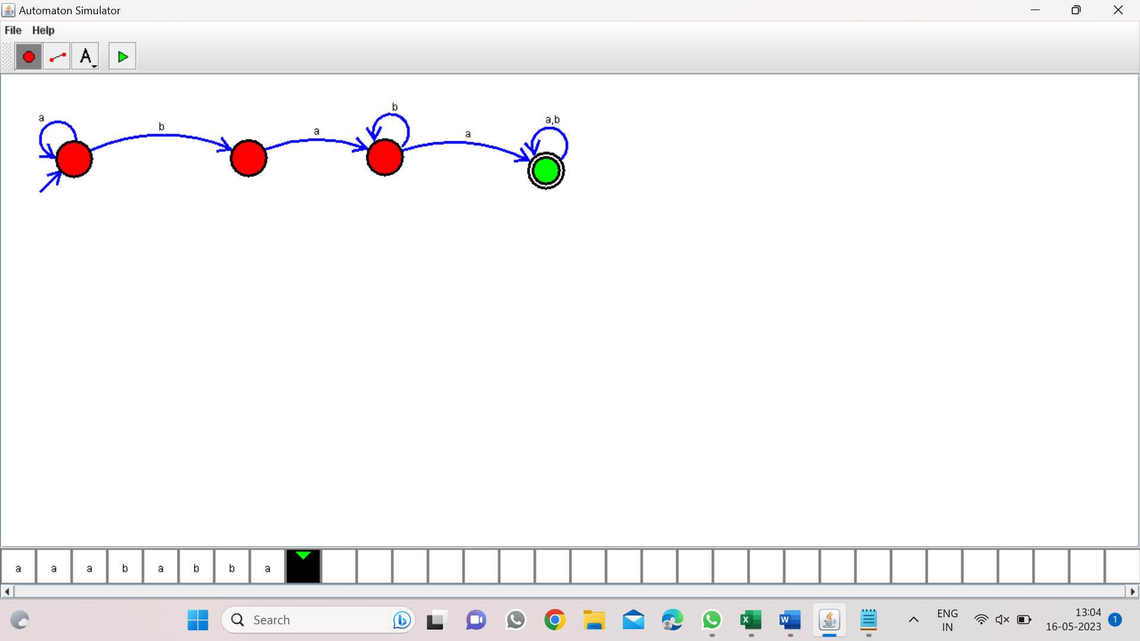

Result:-

From the above DFA diagram valid the substring having ab